How to setup Tenda DH301 Dynamic IP mode
Product line: ADSL Model number: DH301
This article will guide you how to setup Tenda DH301 Dynamic IP mode and the steps as below.
Note: If you have no idea about what is the internet connection type, please call your ISP for them.
Part 1: Connect the devices
Part 2: Configure your computer
Part 3: Setup the router
Part 4: Check whether you can access internet
Connect the broadband line with the WAN port of DH301, and then connect your computer with LAN port of DH301 by a cable.
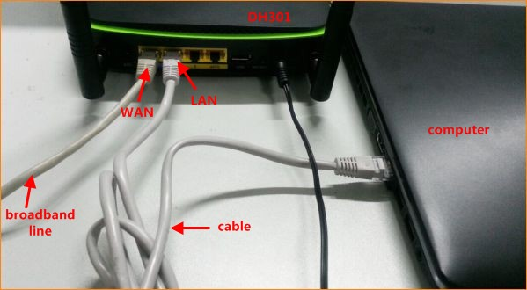
Note: after connection the SYS light should be blinking, the WLAN light should be on or blinking, the LAN, WAN light should be on or blinking.
1 Click on Network Connection Icon on the system bar, then click on Open Network and Sharing Center.
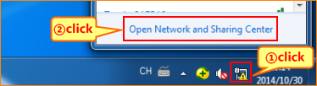
2 Click on Change adapter settings.
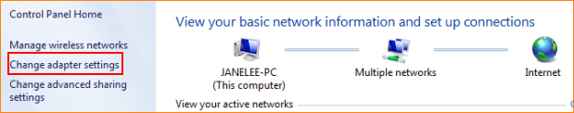
3 Right click on Local Area Connection, then choose the Properties option.
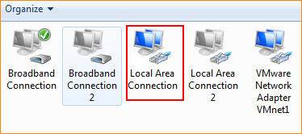
4 Double click on Internet Protocol Version 4(TCP/IPv4).
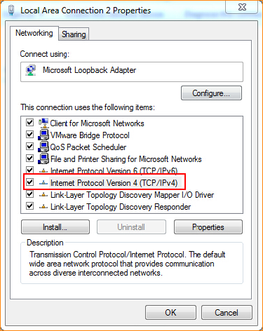
5 Choose Obtain an IP address automatically and Obtain DNS server address automatically and then click OK.
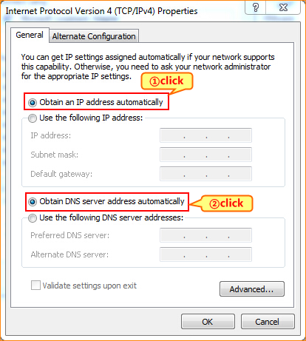
6 Also click on OK on the first Local Connection Properties window.
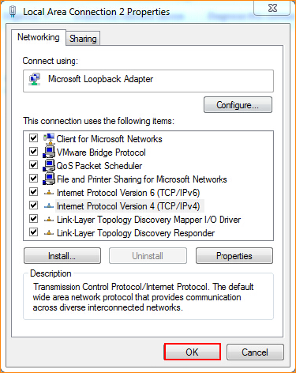
3.1 Setup the router in home page
3.1.1 Open a browser then type 192.168.1.1 in the Address bar, click on Enter.
3.1.2 Type the Username and Password as admin in the bars then click on Login to login the setting page of the router.
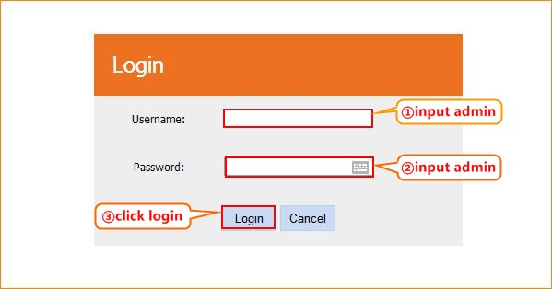
3.1.3 Setup DH301 in home page, choose ETH, IPOE (1483 MER), Dynamic IP. You can also change the SSID and wireless key, and then click OK.
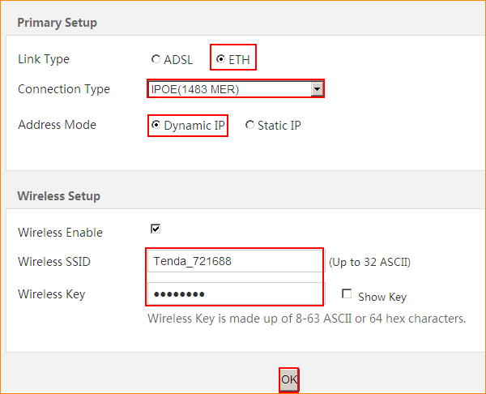
3.1.4 Click on Advanced on the right of the page to login the advanced setting page.
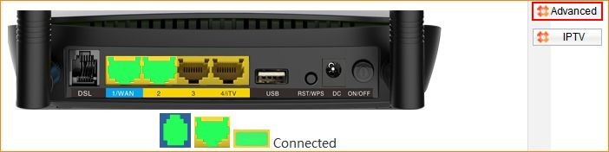
3.1.5 Click on Management and Reboot then hit on the Reboot button to reboot the router for refreshing the device info.
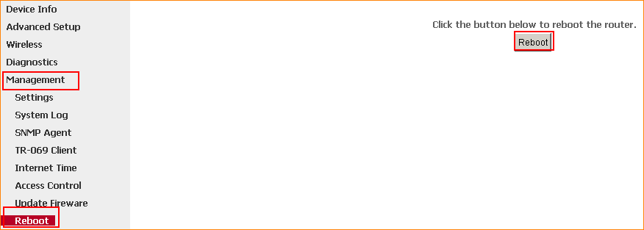
3.1.6 After reboot, Click on Device Info, WAN, then check the WAN Status if the Connection Status shows Connected that means you can access internet, please check.
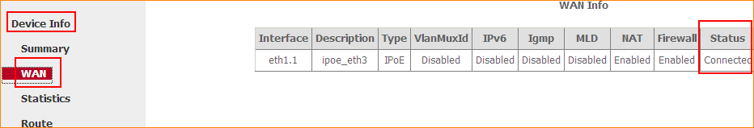 If you can’t, please click here and follow the steps below.
3.2 Setup the router in advanced settings page
3.2.1 Click on Management and Settings, Restore Default then hit on the Restore Default Settings button.
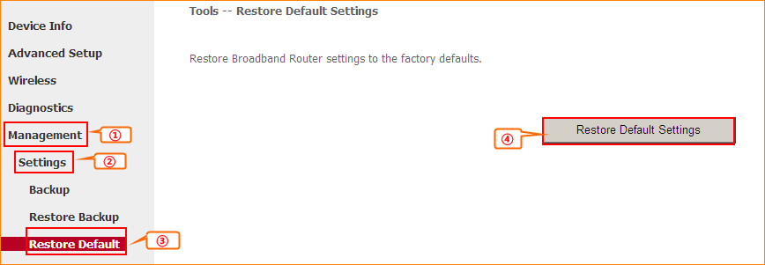
3.2.2 Click on Advanced Setup, Layer2 Interface, ETH Interface and Add. And keep the default setting, click Apply/Save. Then you can see ETH WAN Interface exists. 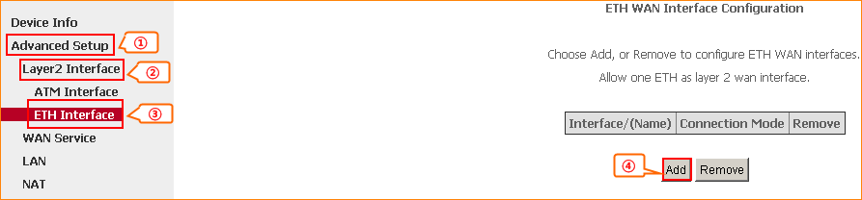
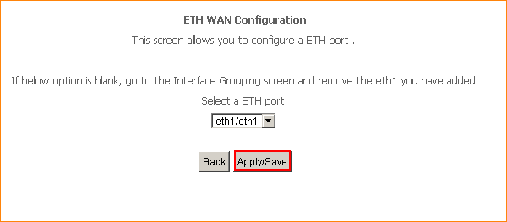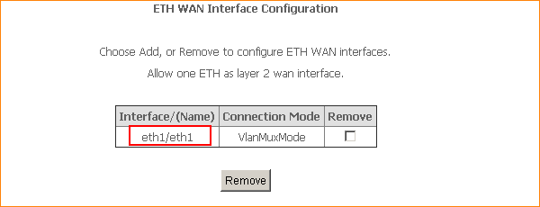
3.2.3 Click WAN Service and Add, keep the default eth1/eth1 and click Next, then choose IP over Ethernet and Obtain an IP address automatically, click Next(keep the default) and click Apply/Save.
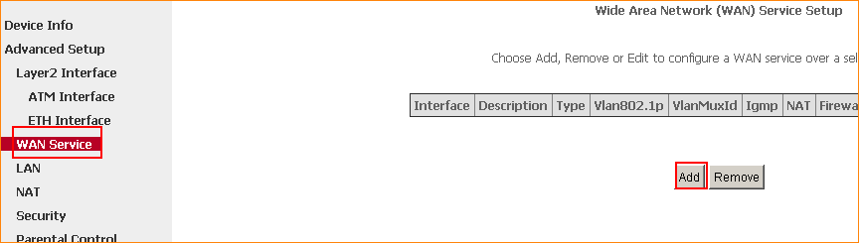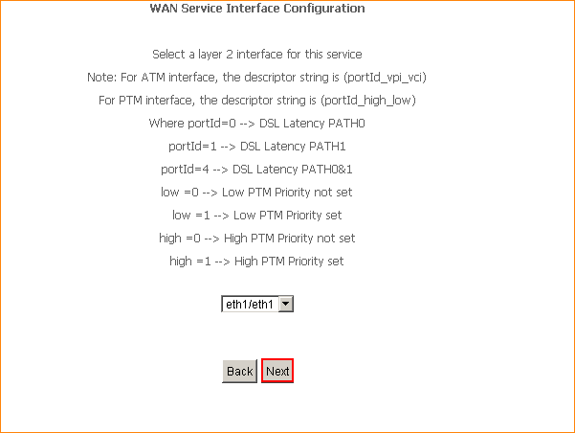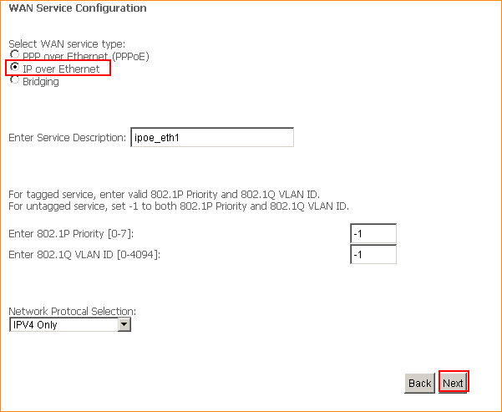
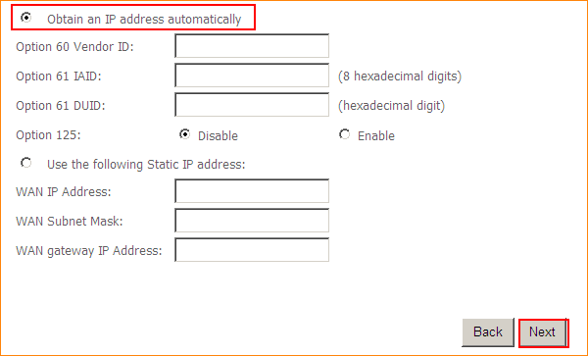
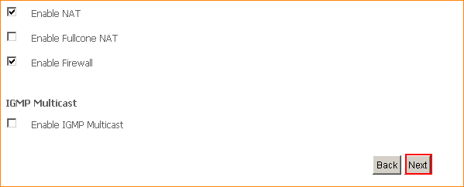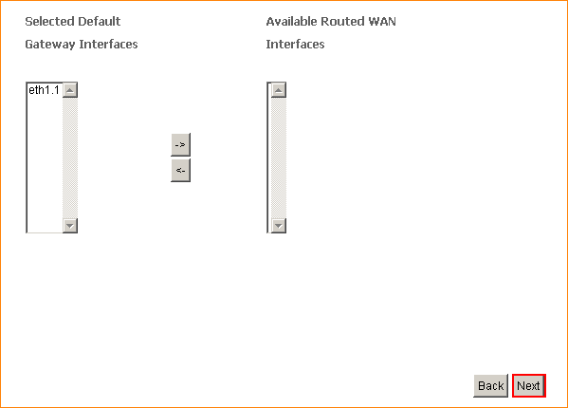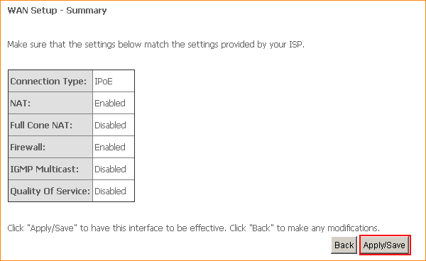
3.2.4 Click on Management and Reboot then hit on the Reboot button to reboot the router for refreshing the device info.
1 Click on Advanced to login the advanced setting page, then check the WAN Status if the Connection Status shows Connected that means you can access internet, please check.

